Human Computer Interaction - 441

**CRAIGSLIST**

By: Neha Goel



# 

# 

# Table of Content

* Project Participant
* Abstract of the Project
* Project Narrative
* Design Considerations
* Mockups
* Testing & Iterative Design
* Challenges of Redesign
* Conclusion

# Project Participant

Neha Goel : All work for the project is done by me only.

Presentation Link: <https://prezi.com/view/YvTxmrxPdJGVkgoUCdSy/>

## ABSTRACT OF THE PROJECT

[Craigslist](http://www.craigslist.org/) is obviously one of the most popular websites in the world, and each month it serves millions of users who post and view classified ads on the website. Despite the fact that Craigslist receives such a huge amount of traffic each month, it is also criticized for its design, which seems to be at least 10 years out-of-date.

This very basic design has also become a **huge part of Craigslist’s branding,** and it helps make the website memorable and instantly recognizable. As a result, the company has benefited in some ways from a design that many people consider to be very subpar. Over the years, as various design trends have come and gone, Craigslist has bucked the trends and stubbornly maintained it’s bare-boned approach.

However, despite the fact that Craigslist has been able to benefit in some ways from its ultra-basic design, there are plenty of reasons to consider making some changes. A simple approach to design and layout that cuts excess and eliminates anything that is less than critical is typically assumed to improve usability.

With Craigslist, however, this is not the case, because the website could benefit from usability improvements in several areas. In the design world, minimalism that conveys a simply beauty is regarded as a very difficult thing to achieve. Minimalist websites can be both attractive and easy to use. However, Craigslist’s design is hardly considered beautiful, even by those who appreciate websites that consist primarily of text.

## What’s Wrong With Craigslist?

Before we suggest any changes that need to be made, let’s look at some of the weaknesses of the current website.

### 1. THE DESIGN IS BLAND AND OUTDATED

As mentioned earlier, and as any Craigslist visitor already knows, the design of the website lacks visual appeal.

### 2. LOGGING IN, SIGNING UP, AND MANAGING AN ACCOUNT IS MORE DIFFICULT THAN NECESSARY

Craigslist has achieved its success due to the huge community of users it has managed to build. According to its fact sheet each month over 30 million new classifieds are posted to the website, and over 12 billion pages are viewed. With this kind of activity level, it’s clear that making the process of creating an account, logging in and managing the account should be as straightforward as possible. However, the current website could be improved in these areas. Unnecessary clicks are needed to do anything with an account, and options on the account page are very limited.

### 3. **SCREEN SPACE IS NOT PRIORITIZED**

One issue with the current design of the Craigslist home page, as well as sub-pages, is the use of screen space. Valuable screen space could be used more effectively in some areas to improve the usability of the website.

### 4. **NAVIGATION**

Craigslist is really a network of smaller websites held on sub-domains of Craigslist.org. Each sub-domain, representing an actual location, has its own board of classifieds. Currently, over 550 cities in 50 different countries are represented. With any website of this size and this amount of content, challenges with the navigation will always exist. Some aspects of navigation are rather effective on Craigslist, but others leave room for improvement.

**For starters, there is no navigation menu that appears consistently throughout the website. Some pages use a left sidebar, some don’t. Some pages are easily accessible from most areas of the website, but not all.** On many of the secondary pages, huge amounts of screen space are left completely empty with very few navigational options. This forces users to hit the “Back” button in their browser to go to another section of the website, something that could be improved by adding more navigational choices on these pages.

## What’s Right With Craigslist?

Of course, a number of things are also good about the existing website, and it’s only appropriate to look at them as well.

### 1. RECOGNIZABLE

Given the amount of traffic worldwide that the website receives, and an appearance that stands out from other major websites, Craigslist is one of the most recognizable websites in the world. When people want to post classifieds online, Craigslist is usually their number one choice.

### 2. CLARITY OF VISION AND PURPOSE

Part of the beauty of Craigslist is that it exists to provide local classifieds and forums, and that’s basically it. There aren’t a lot of extras and options, and there are no ads on the website. Craigslist exists to help people find what they are looking for, and to help people find other people who want what they have, and it does this better than anyone else. The people running Craigslist have not been distracted by other monetization opportunities or other things they could be doing with the website, and they deserve to be commended for sticking to their purpose.

### 3. RELATIVELY EASY POSTING PROCESS

For a website that relies on classifieds being posted by individuals, **Craigslist makes the process fairly straightforward and simple.** On community pages, there is a clearly marked link for posting classifieds, and users are led through a simple and efficient process once they are logged in. The only drawback here is that you have to navigate from the website’s home page to a local community page before seeing the link to post a classified.

### 4. PAGES LOAD QUICKLY

Visitor to the website will appreciate the speed with which pages load. This is especially nice as you’re browsing classified listings and visiting a number of different pages on the website.

# PROJECT NARRATIVE

## The Goals

Before starting any type of evaluation, it’s important to clarify what exactly we hope to accomplish. In this case, our purpose is two-fold. First, we want to improve the **usability** of Craigslist by making some minor changes that will result in a more positive overall user experience. Secondly, we want to create a **design and layout that is more up-to-date and pleasant to look at.**

**Recommended Changes**

1. Typography

2. Colors

3. Organization of data with Pleasant Interface

4. Proper Navigation

5. Adding Recommendation System i.e Most Popular while browsing for Subcategories

6. Proper Organization of Images

7. API of Social Media during Login

8. Making Posting Ad easy for the user

**Comparison with Competition**

Although Craigslist is the one of the most popular website with millions of users worldwide there are still some competitors in the market who score better just because of their good UI. But also there is a fact that because Craigslist is a one soul platform for so many areas that we have different companies for each area and not any 1 for as craigslist because of which with the most simple UI it is the most popular. Below is the pic I encountered showing the competitors of craigslist:

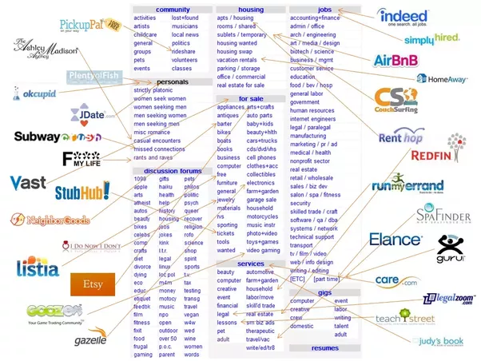

# 

# 

# 

# 

# 

# DESIGN CONSIDERATIONS

# Colors

The current design of Craigslist uses very little color. In fact, aside from the default colors for links and text there is virtually no color at all. The page has a very light gray background, and slightly darker gray boxes are used to make certain pieces of text stand out. The website contains many links in the browser default color of blue. That blue is really one of the distinguishing marks of the website as a result of the sheer number of links and lack of any other color. Visited links are displayed in purple; and when hovered over, links are shown in purple with an underline.

In attempting to improve the design, some modification to the color scheme is justified. However, to keep the identity of the website intact, I have mainly used colors in Header, footer, buttons and important. I made sure that the colors are significant for the color Blind people and are proper for contrastings. In the initial mockups i used green which was not proper so I changes to the sunny Yellow and other colors.

Below are the colors I Used for fonts and layout.

## 

## 

## 

## Typography

After the initial mockups review i worked on my fonts a lot. I used the fonts so that user can read properly. The contrast of the Colors of the font with the background is done such that the letters are not bright and is clear and easy to read. Proper Spacing is provided where the section is data oriented for example footer, subcategories etc.

## Iconography

To give the Design a stylistic look and provide some colors to the main layout I designed some colorful Icons. Also the readers who are not able to understand the meaning of the writes can understand easily with the icons.

***Icons for posting ad***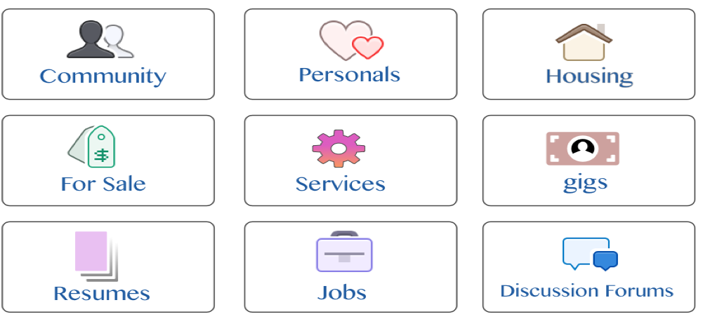

## 

## 

## Layout

In the current design the main issue is the improper layout of data. Organizing the whole lot of data in a proper and spaced way was the biggest challenge.

### Header

In the Header before login the Logo, Post Ad and Login are the features added. Reason being these are the important things the User looks for when he needs to either login or Post Ad. After login the User’s My Account, Event, Place, Post Ad and the Logo are compiled in header. As the Header embarks the first look for the user i gave it the brightest color if yellow and some bold and clear fonts of colors.

### Footer

The footer consists of all the links that the user might require for further exploring the website. In the current design these links are scattered all around the page seeing which it becomes quite confusing to search for the links. I grouped these links into categories of About, Support, Extras & Get in touch accordingly so that it is easy for the user to look for the specific link required.

### Main Page

The Main Page for all the pages consists of all the categories, subcategories , the products, Products description etc. It is the place where all the data scattered on current design is organized and placed in a proper fashion. Due to high visibility I preferred White color as the main background color. Although i do gave colors to fonts, Icons and buttons according to their priority.

## Tutorial

While researching for Existing Tutorials of Craigslist original Version i found many interesting tutorials made by the users of the craigslist. Below are the links for some Existing Tutorials:

* <https://craigslistpostingsecrets.wordpress.com/craigslist-posting-tutorial/> ( People have written wordpress blogs on its usage)
* <https://mollermarketing.com/2009/01/tuesday-tutorial-selling-products-on-craigslist-a-step-by-step-guide/> ( A step by step guide for the users )
* <http://www.wikihow.com/Sell-Items-on-Craigslist> ( A wikihow post of it)
* <http://www.beatcraigslist.com> ( I think this is the most interesting blog for Craigslist)

Considering the above available tutorial I added following in my new design:

* Firstly I added a proper Step by Step guide under the Help section in my design so that there is no requirement left for the users to write the tutorials and blogs. Tutorials should be available on the site itself.
* New Design Aspects of different Pages, Recommendation System added in the tutorial.
* Adding of a Video Tutorial in which a video tour of the Site.
* Adding Automatic Hints and Tips for the Users when the user go to a specific page describing what all he can do on the certain page eg Tips on Posting Ads Page

## Gamification

Yes We can implement some gamification aspects in tutorial as well as on the Website.

Gamification is a user experience enhancer built around the 3F framework - Fun, Friends and Feedback. So in this case, we will need to make our classifieds site a fun experience (*yes, craigslist is boring!*), making sure that people are socially connected to increase virality and ensure that we provide the users feedback through rewards.

A simple way to integrate gamification into any site would be using the simple PBL strategy of Points, Badges and Leaderboard - This will lead to the creation of high consumption users who will actively use our site to ensure they are on top of the leaderboard, and individual points and badges will make sure people come back to our site/app when they wish to interact with this genre of application

Few first steps I implement :

1. Create a user identity system that will provide points for every interaction

2. Try and increase interaction by providing points for interaction (eg: daily visit, classified viewing, posting ads, buying through the site)

3. Special badges for particular achievements (viewed an ad in your area, viewed an ad in other area, viewed ad in a particular segment etc)

4. Create an objective list (Eg: View 10 ads in NY, View 25 ads in USA etc)

5. Increase virality by asking users to share on FB/Twitter/Pinterest and incentivize them through the point system

6. Create Leaderboard - Global, national and local

7. Allow users to redeem these points for discounts or special privileges

## Patterns

I choose the Home Page. In the original/current version of Craigslist i think no specific proper pattern is used or i can say a deconstructed F pattern is there.

In the new Product i redesigned the HomePage into two Pages - Home and Subcategory. The Pages here will follow the proper F Pattern. As the user will start at the top left corner with the Main Logo then scanning towards right for Posting add and login option. Next they move down again from left to right for searching the item they need and the the search button at right. Scanning down on all categories in left and other useful links in the footer.

## Laws of Gestalt

### **Law of Pragnaz**:

Craigslist follows this law as the current design of Home page s very simple and it tries to give the whole information at once at one place.

### 

### Law of Proximity

Craigslist recent home page uses this law by keeping all the things on one page close to each other. For example to make it easy to understand which all categories falls under “for sale” category. I also continued to use this law in my redesign.

### **Law of Similarity**

Craigslist recent Home page does not follows this law totally. It has groupings of few categories in the center but the green button search and other parts of the site are not grouped in a similar manner and are scattered in right and left menus. In my new redesign i tried to follow this law and do a grouping of similar categories.

For eg: in the center are the categories, with the search at the top and the event calendar in same level with categories. And the other items grouped in small areas in footer.

### Law of Closure

The law is used in few pages of the current version of the Craigslist. For example if we browse the “forum” category at first it will not be pretty clear where it will lead to, due to the next design : On clicking the Forum on Home Page it displays the below page with only the categories listed ( an unfinished line). According to the user previous knowledge on clicking the first forum subcategory - “android forum” it leads to a next page. At first it was not sure what these two columns indicate but after clicking on various threads in right column and its subsequent displays in right column it made the user understand the exact flow. I think the law of closure is used but it does not look good at all and is difficult for the user to understand the flow at once.

### Law of Common Fate

The Law is used in 2 ways in current version of the site and will be using it in the redesign as well. In the current version the images of Posting Ad can be added manually by uploading or there is a feature of drag and drop to add images. As there was a limitation of adding single images in current design I gave the user option of adding multiple images with drag and drop option while posting ad thus completely following the law of common fate.

Second way is there is a carousel added for moving the pictures that are displayed with various items representing the law of Common Fate

### Law of Continuation

The law of Continuation is not followed in the current version. But in my new redesign i followed it in my subcategories page. The categories are designed as the left menu and an arrow will determine the subcategories. The continuous flow/hovering on categories and a flow from the categories pointing to their respective subcategories follows the law of Continuation ( perceived by users of belonging together).

## Visibility

1. The current version of Craigslist is White for a good visibility. In my redesign i continued with the White Background. Although i did change the colors, the organization of categories and the content placement. In the current version there is no use of Icons and is pure text in same color and in a confused way. I tried to improve the visibility of the UI by placing icons along with text, by dividing the content respect to the location on the page.

2. Craigslist main green button is the search and post. Users come there either to search content or to post ad. In the current version these two main functionalities were not so highlighted which i improved.

3. While the user is posting add it was not so clear what all steps to be taken which makes an ambiguity in users mind as to what all is needed in the posting an ad. I redesigned the form in the manner that user can get on the first hand all the steps required.

4. The use of breadcrumbs was no consistent in all the pages of the website which is a confusing point for navigation. I implemented the use of breadcrumbs on every page so that it is easy for user to navigate back and forth.

5. Also for a better visibility and understanding my design will have a hovering option such that when the user hovers over an article or category it describes in short what the topic is about and what type of content user can expect when he will move further.

## Feedback & Constraints

### 

### Activational Feedback:

1. The highlighted and bold search button which shows a movement when the user clicks on the button.

2. Highlighting of the Categories when the user hover or clicks on that particular category.

3. Highlighting of the subcategory and its content displayed in the dynamic side menu reflecting the content of the subcategories.

4. Currently manual slider is implemented for images in the ad posted, changing it to the automatic slider of images once the user is on the page of the ad.

5. During the posting of ad and signing up of the account, list of available options and required features.

6. Currently while posting ad if we select an option it directly redirects to the next page without the user’s confirmation ( by clicking on continue) . Thus removing this feature so that user can select the option and can move to next page when he selects Next button, giving user the option to change his choice of option.

### Behavioural Feedback:

1. While posting ad provided Confirmation Dialog box before publishing the ad.

2. After posting ad Showing the link to edit and delete the ad.

3. Currently if a user post its ad make his account and returns back there is no proper way of showing the history or track of all the ad he posted. So implementing a User page with all the progress and track of the account, his ads, options to delete the ad.

4. Adding Google, Facebook, Twitter login and signup options.

### Constraints:

1. When the user has selected a particular city then he can post or search ads for that particular city only.

2. User can only view the posted ad but can contact the owner of the ad only after logging into his account.

3. Few options enabled when the user logs into the site like editing his post, adding comments and contacting to other users ad, participating in the forums.

## Robinson’s Model of Competence

I am redesigning the craigslist interface keeping in mind the increase in competence factor. In the current version of craigslist the main missing factor is the competence. I tried to increase it by designing it in a manner that the user feels more comfortable on visiting the website. He should not be confused as to where to start and how to search or post adds.Considering the 4 stages of Robinson’s Model of Competence:

### 1. Unconscious Incompetence

The stage where the individual does not understand or know how to do something and does not necessarily recognize the deficit. They may deny the usefulness of the skill. If we look into the current version the user of this stage might not able to encourage toward progressing and will be held on this stage ever as the current version is very confusing and does not encourage user to move forward. Although i would say that due to increased usage of the purpose of craigslist is very high and demand users are kind of bound to come to the site. To improve the user’s unconscious competence i designed it with some pleasant colors and more icons and cleaned up first the home page as the user who does not know anything can at first feel comfortable on visiting the website and can easily signup.

### 2. Conscious Incompetence

The stage where ,Though the individual does not understand or know how to do something, he or she does recognize the deficit, as well as the value of a new skill in addressing the deficit. At this stage my redesign will encourage the user to explore the website. The division of the categories and the subcategories page, the organizing of the content will encourage the use to search and understand the vast variety of classifieds posted on the website. He will be able to differentiate between different types of ads and tries to post new.

### 3. Unconscious Competence

The individual understands or knows how to do something. However, demonstrating the skill or knowledge requires concentration. For this stage there are users who knows what is craigslist, what is the use of it &c. But if they visit the current website they kind of get lost as how one can explore and make it use. To encourage this i proposed the design of Help guidelines and a small tour tutorial that can easily convey idea behind the website and also helps the user to give an idea of all types of categories.

### 4. Conscious Incompetence

The individual has had so much practice with a skill that it has become "second nature" and can be performed easily. As a result, the skill can be performed while executing another task. Craigslist can be a site for many such type of users. The users who frequently post ads for their sale, connect with other groups, check and post jobs, take part in various forums &c. For such users it is essential to give a user friendly and a beautiful UI which encourages them to continue their work. I redesigned the site with color, UI ethics and tried to design the pages more user friendly, fast to browse and pleasant to the eyes.

# MOCKUPS

### Current Design

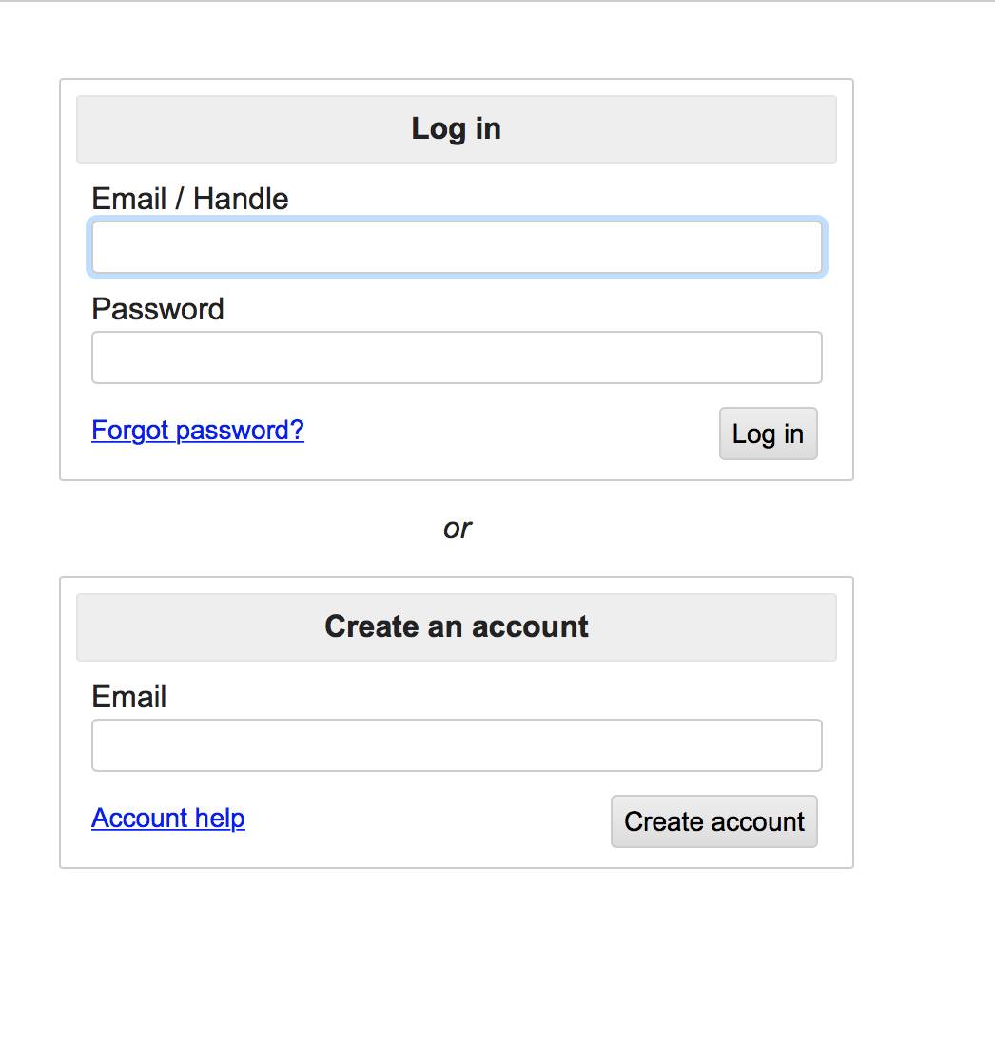 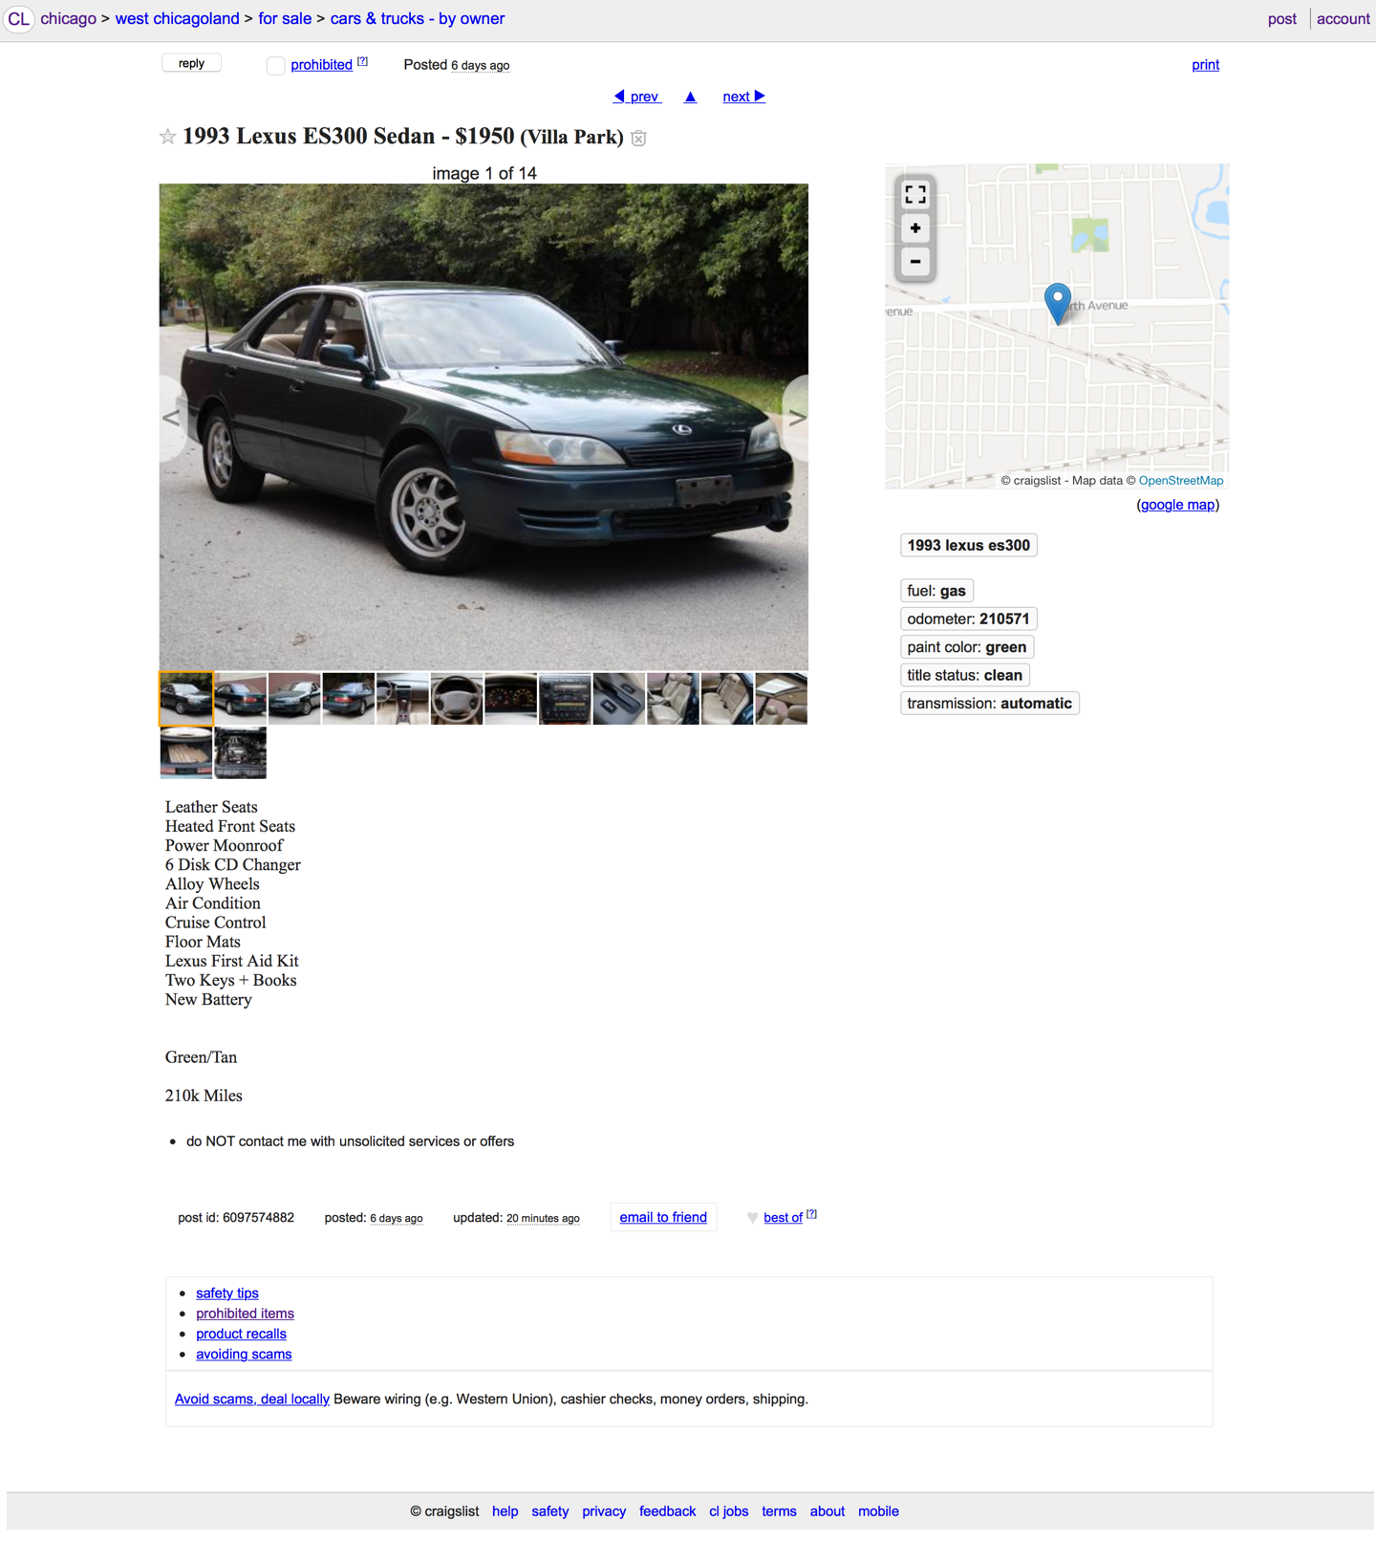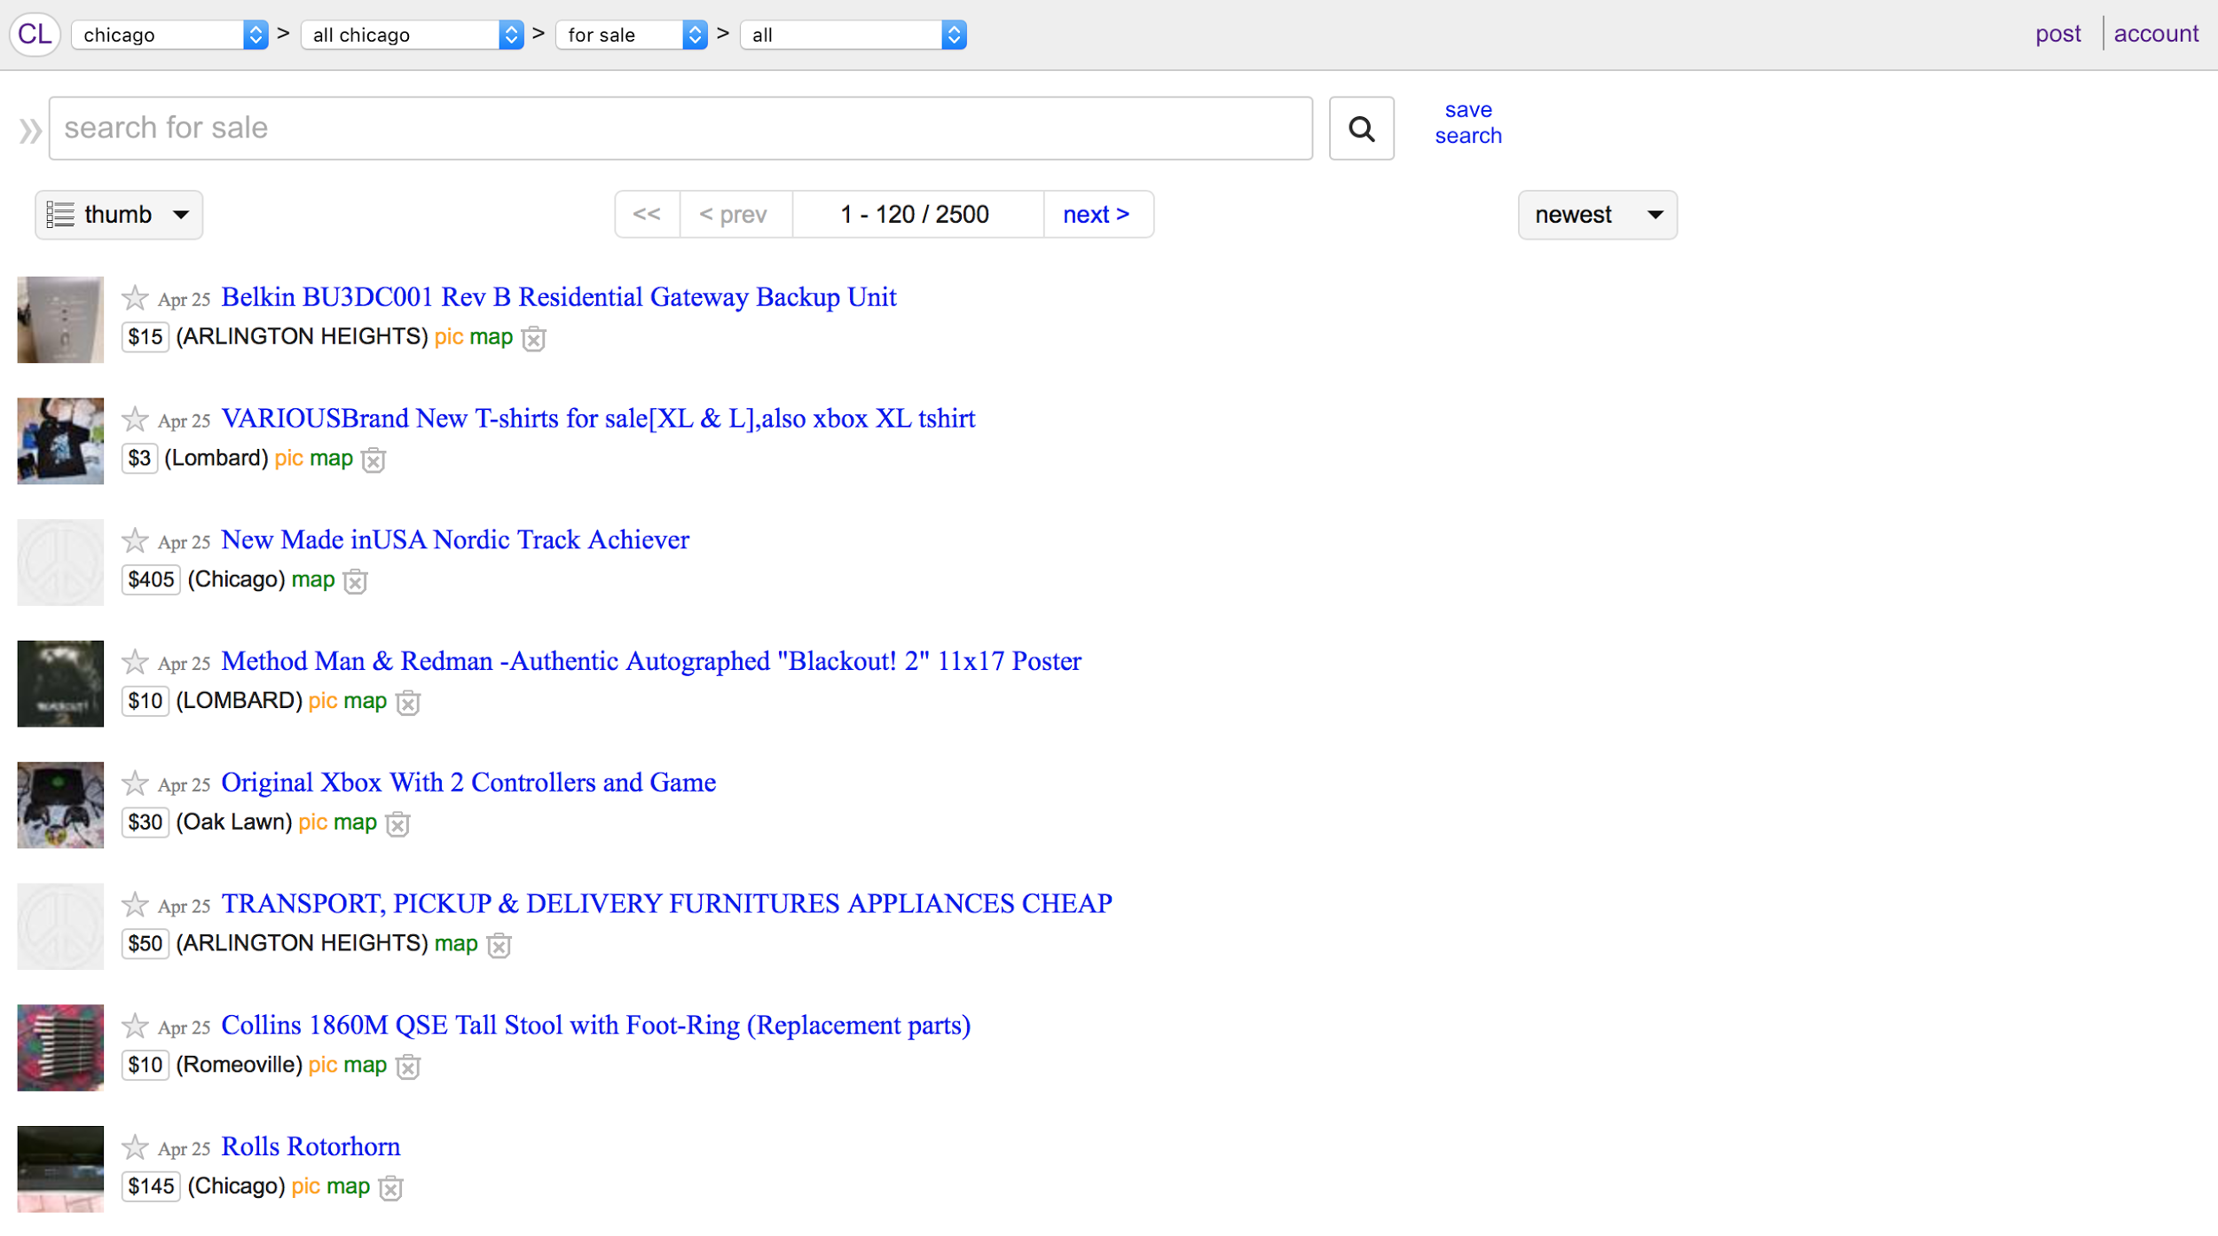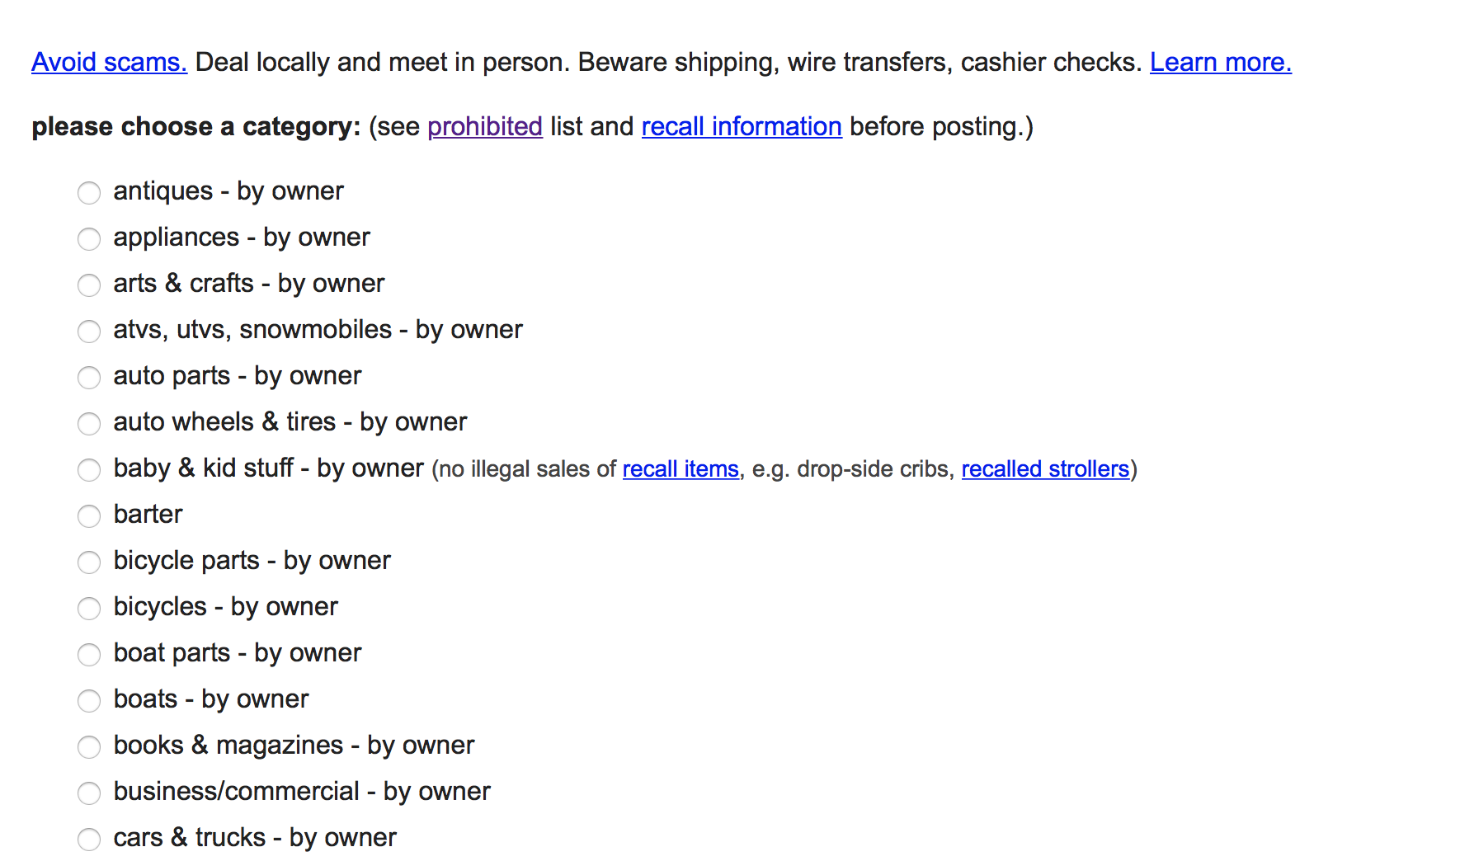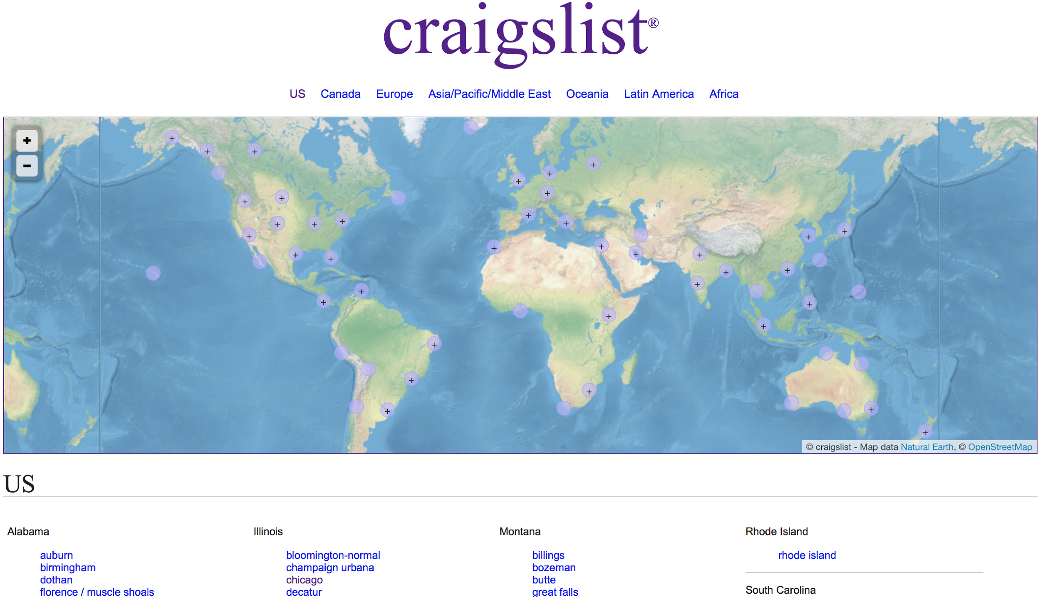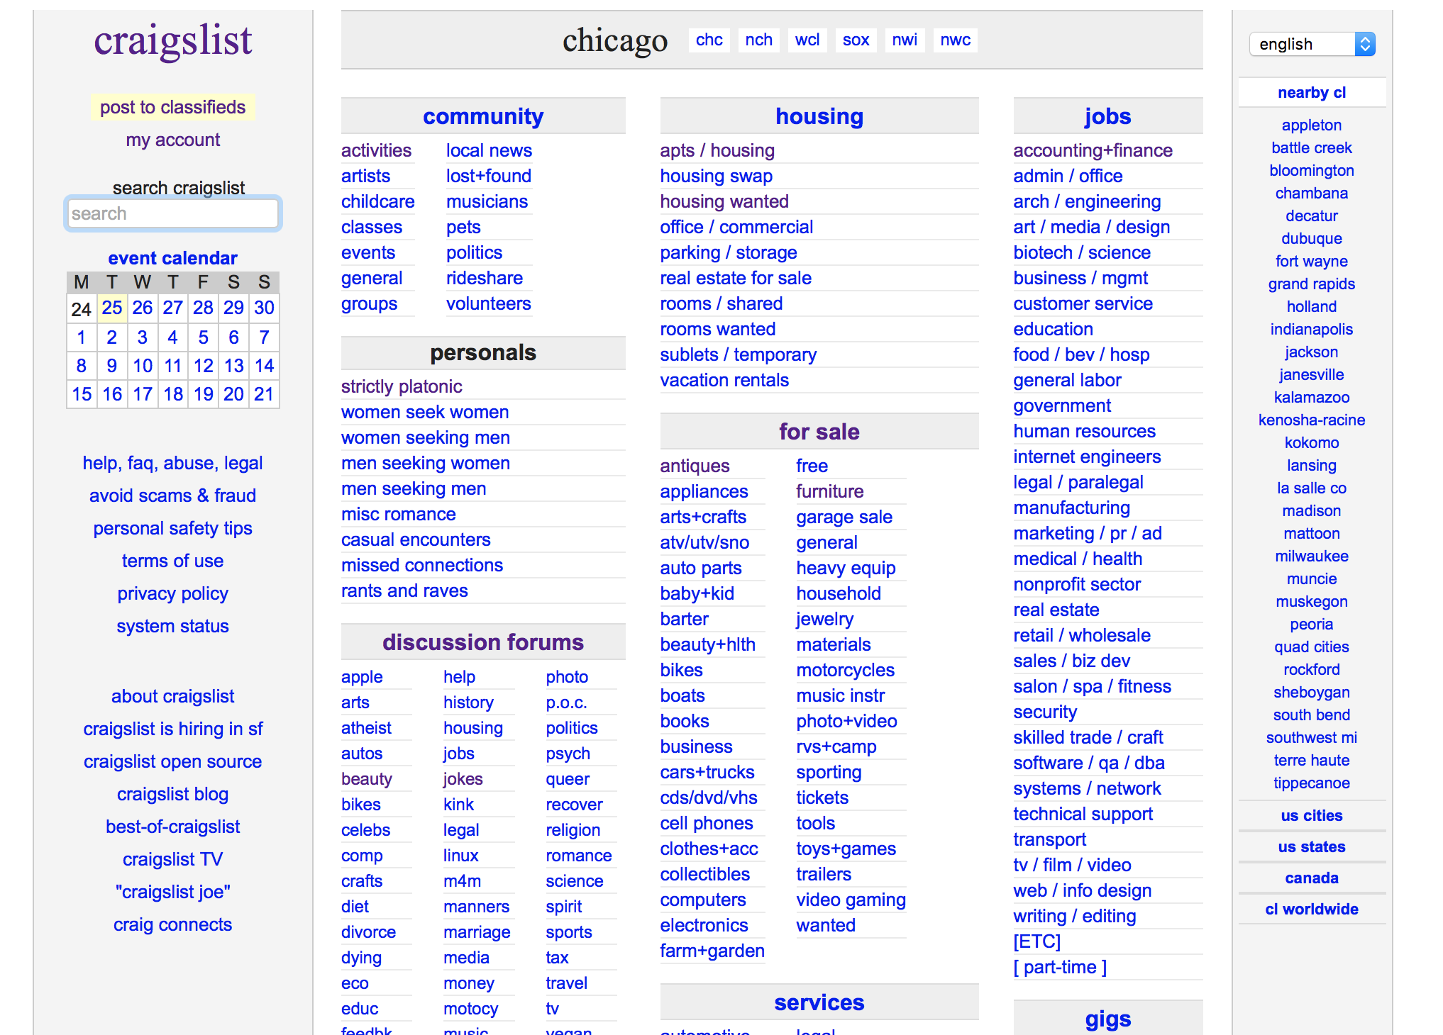

### 

### Initial MockupsDesktop HD.png

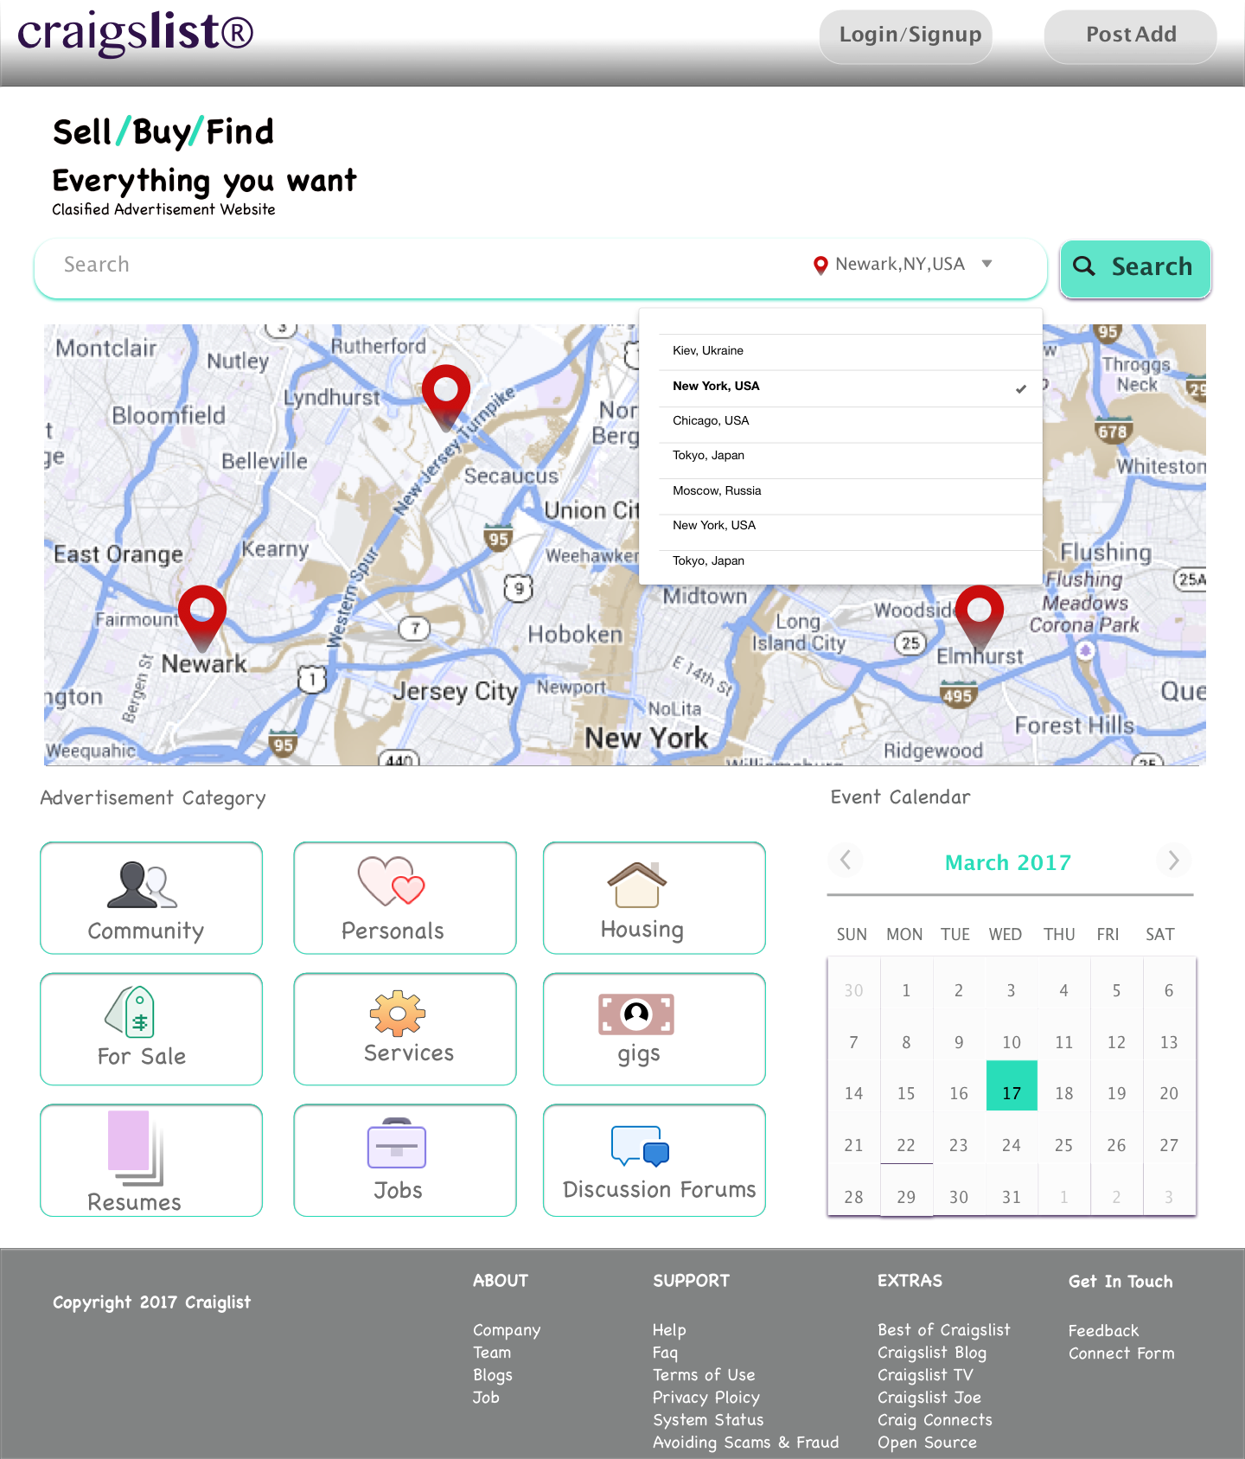

### 

### 

### 

### 

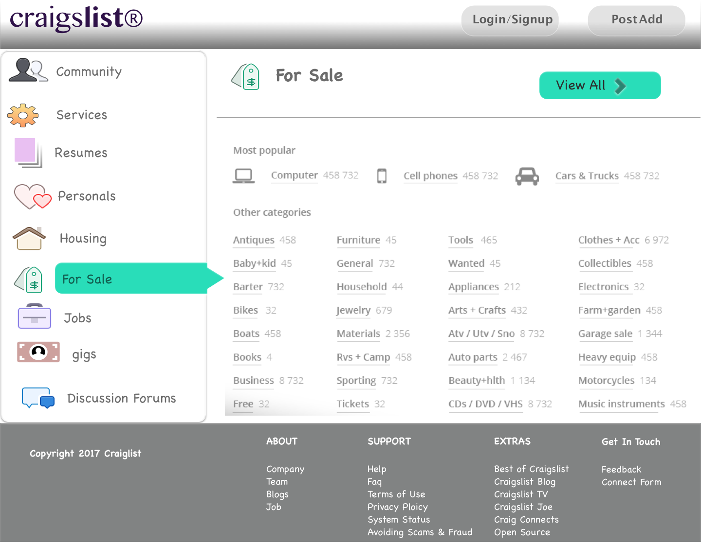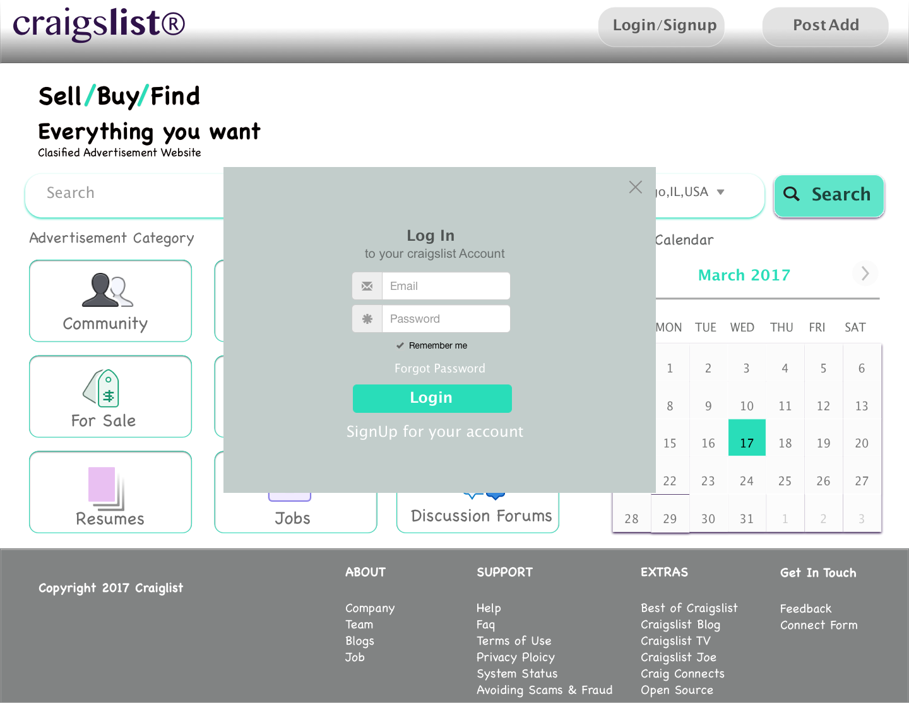

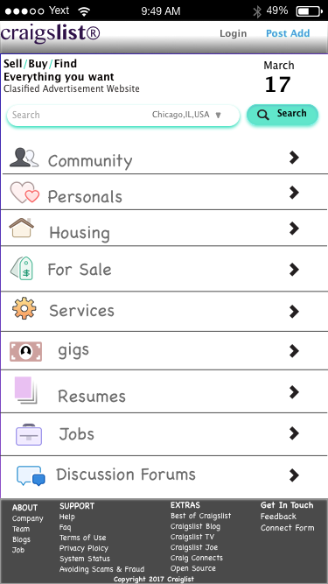

### Final Redesigned Mockups

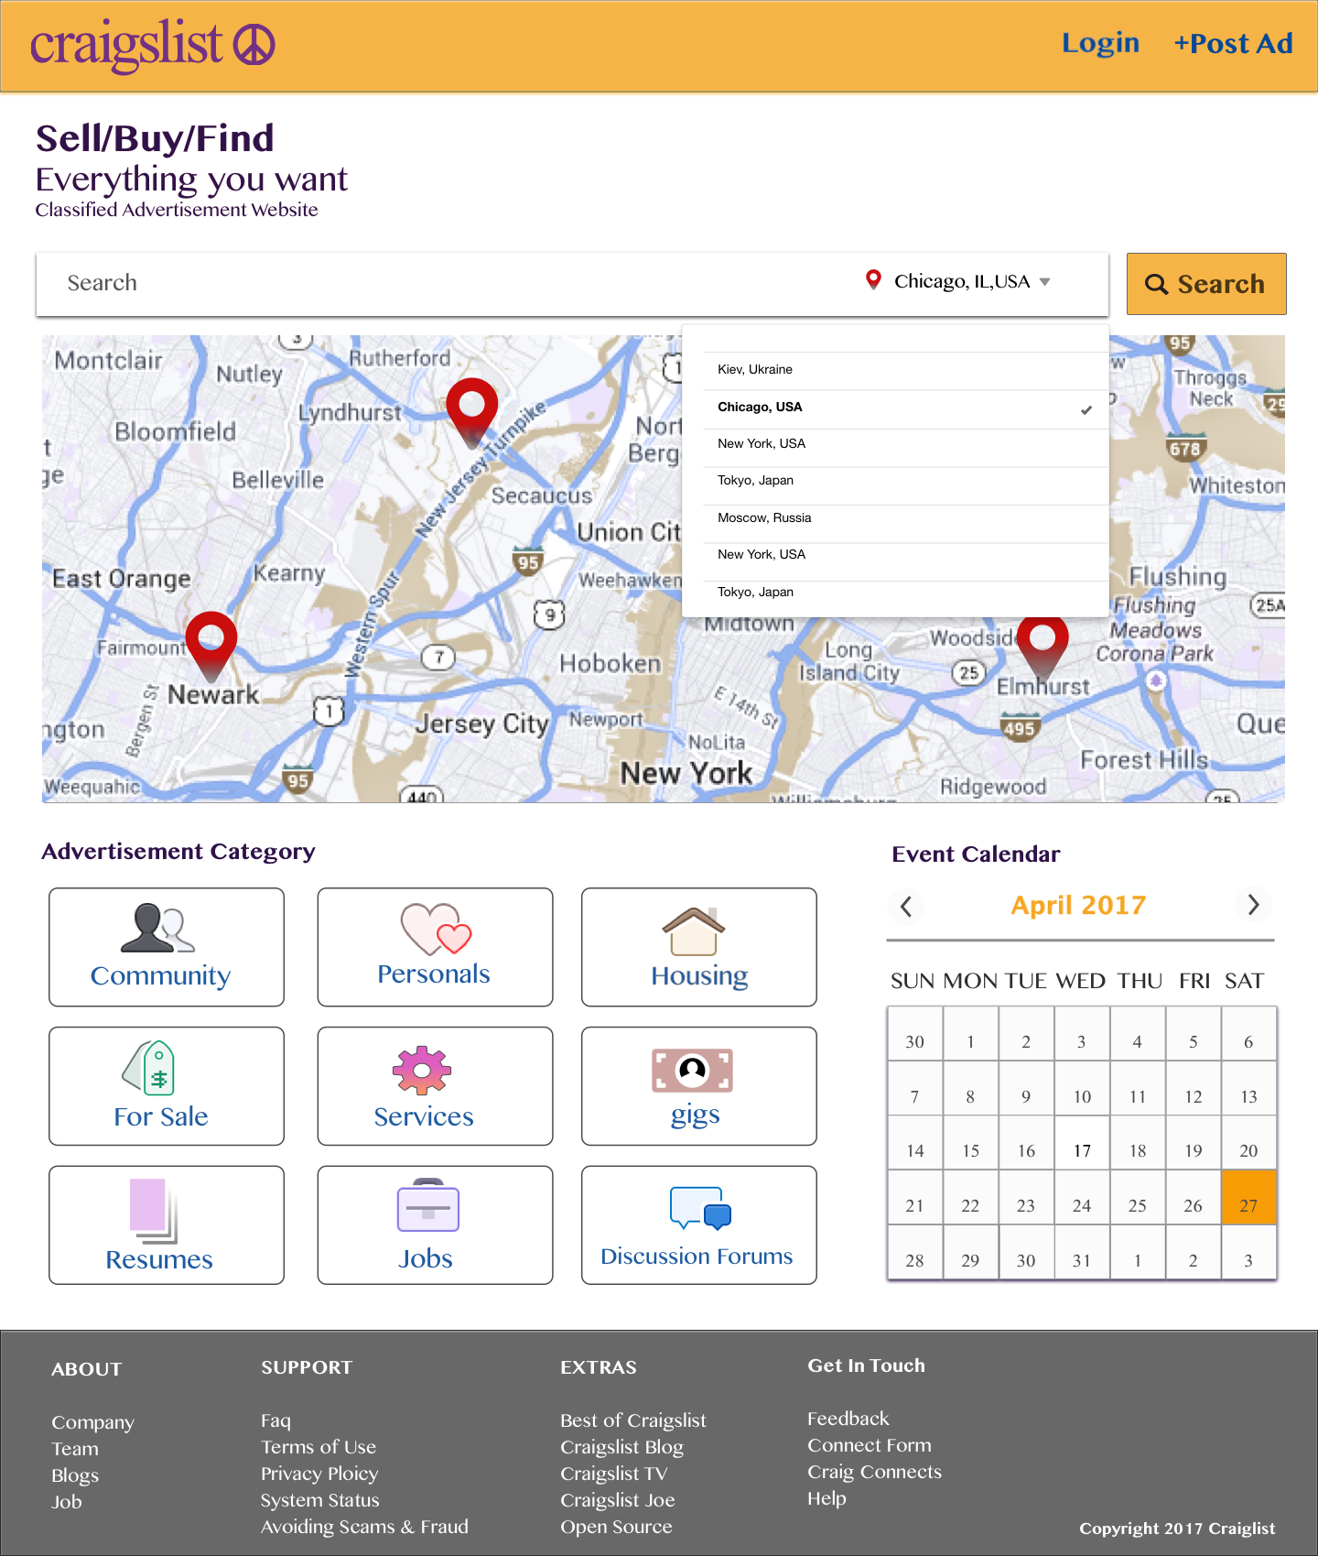

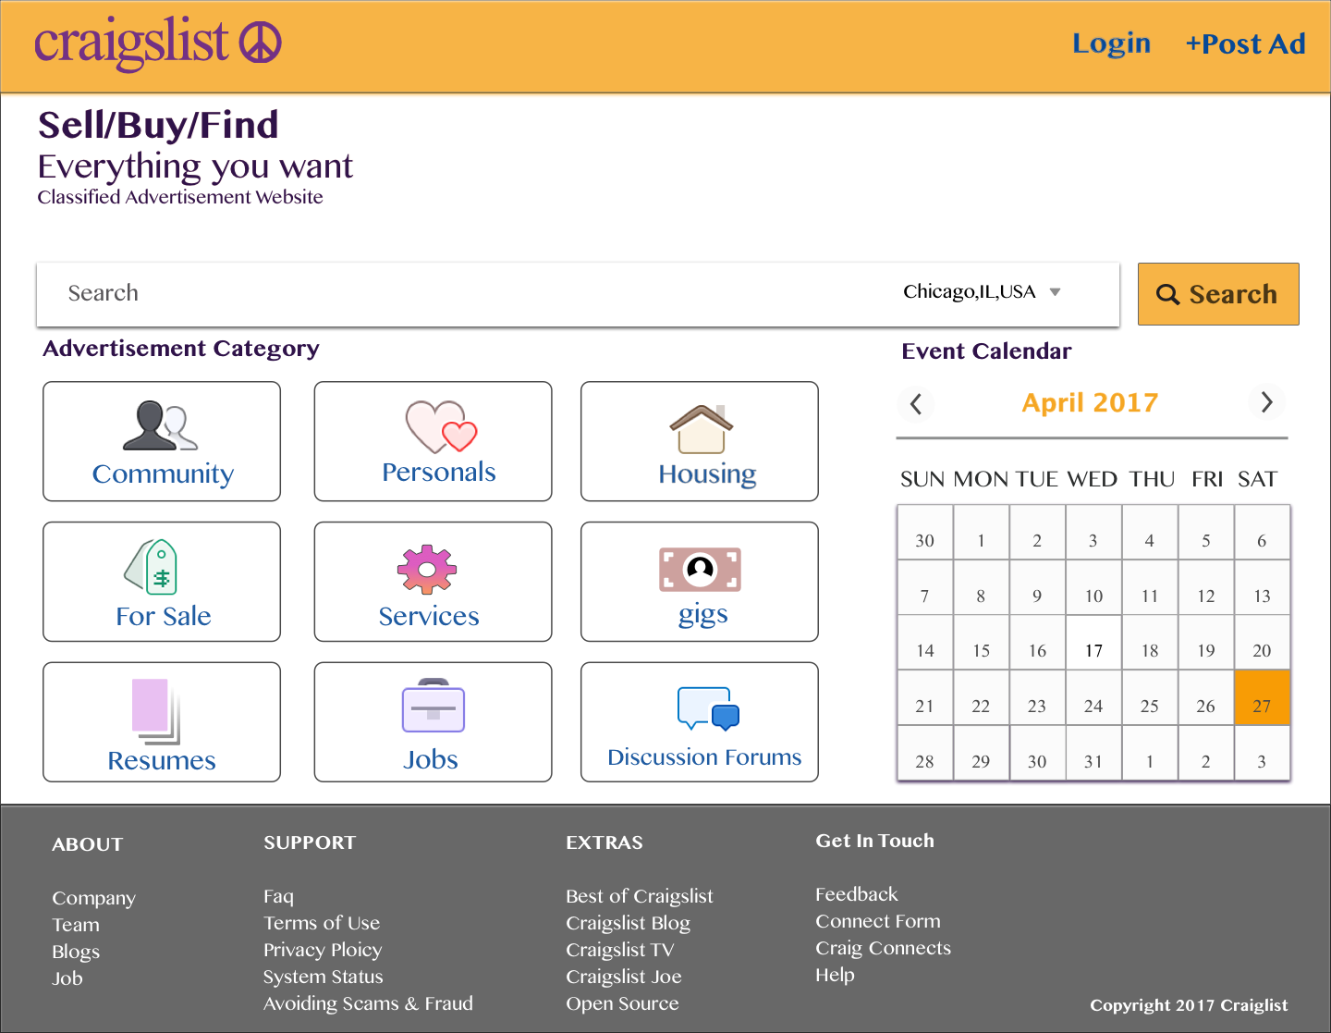

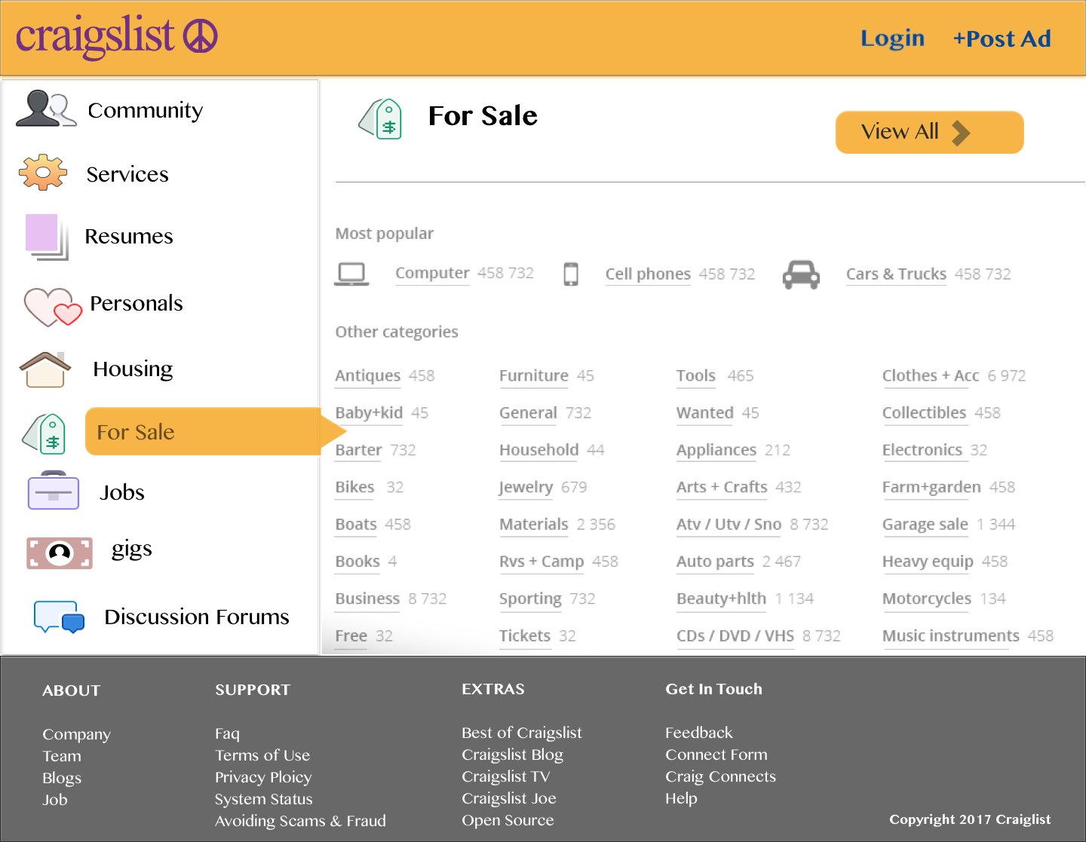

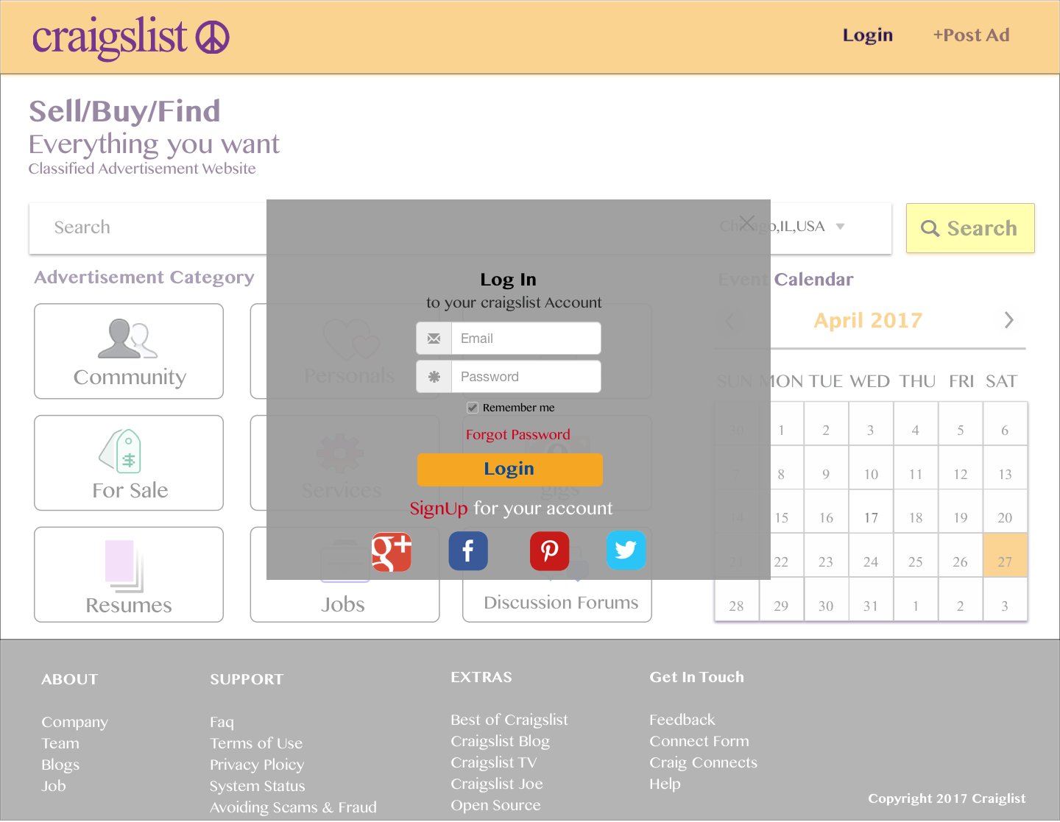

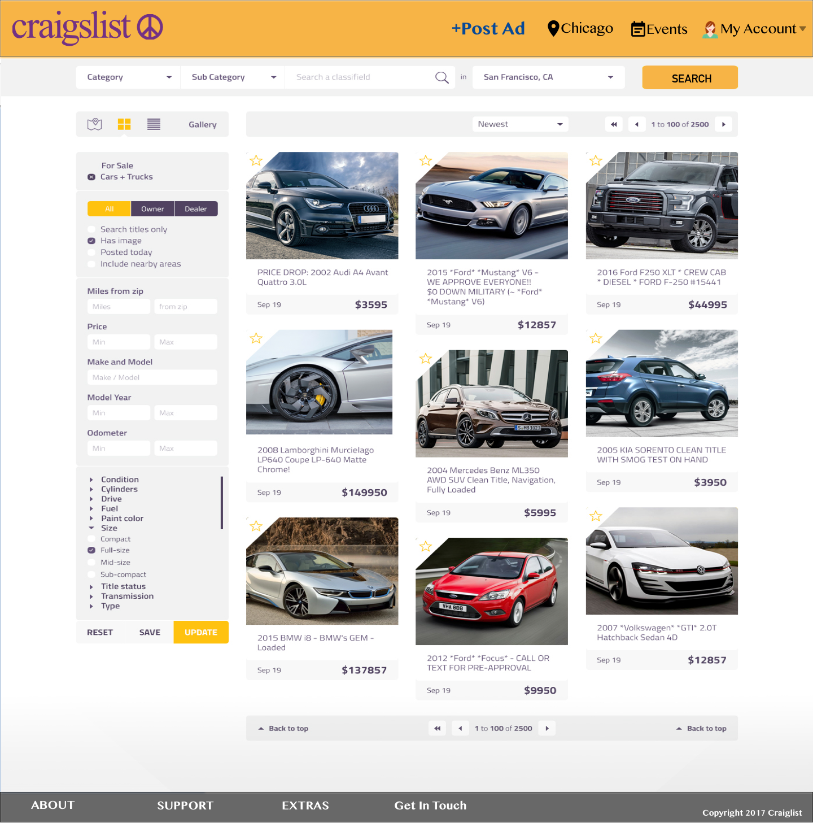

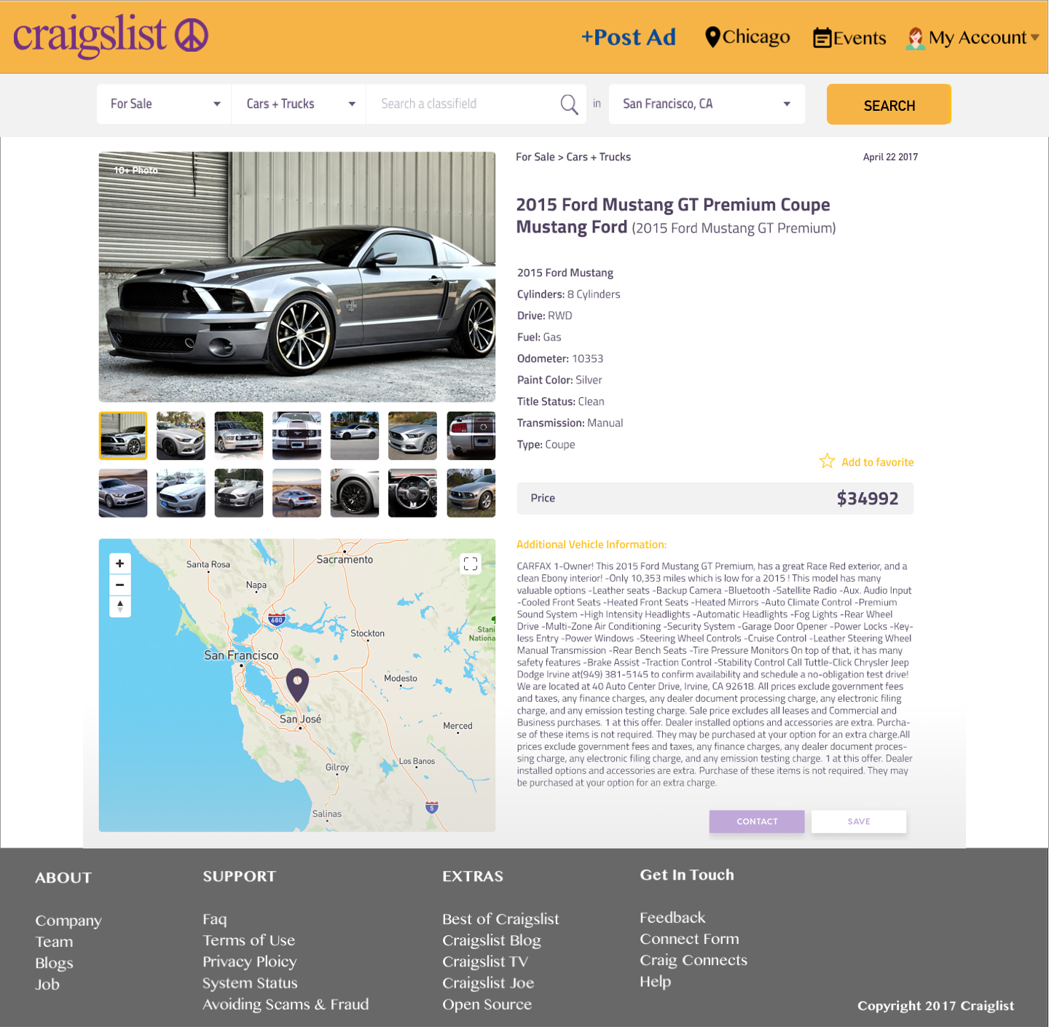

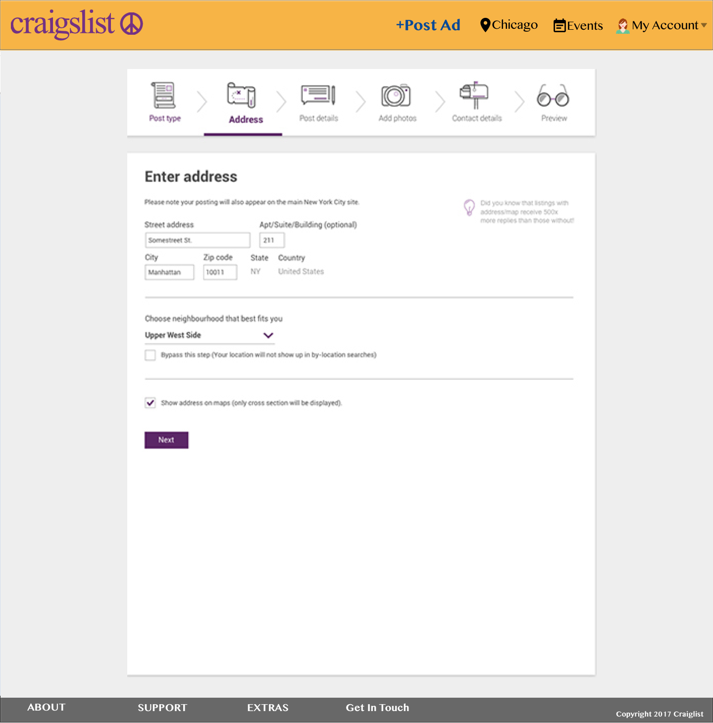

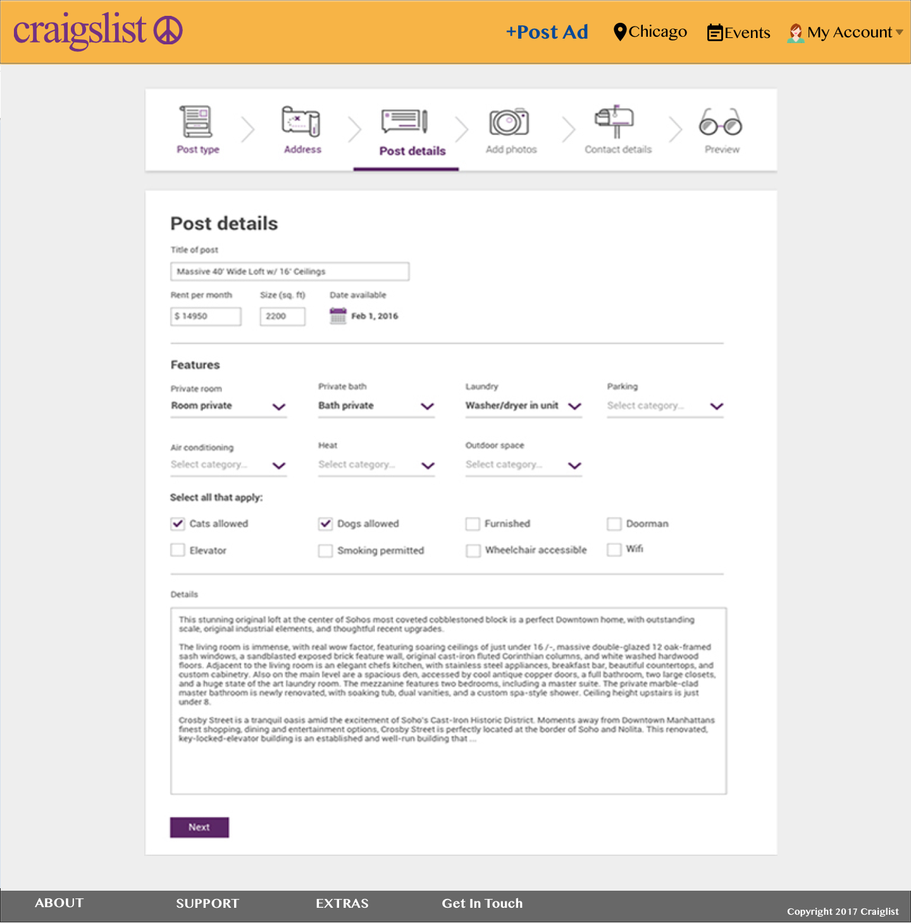

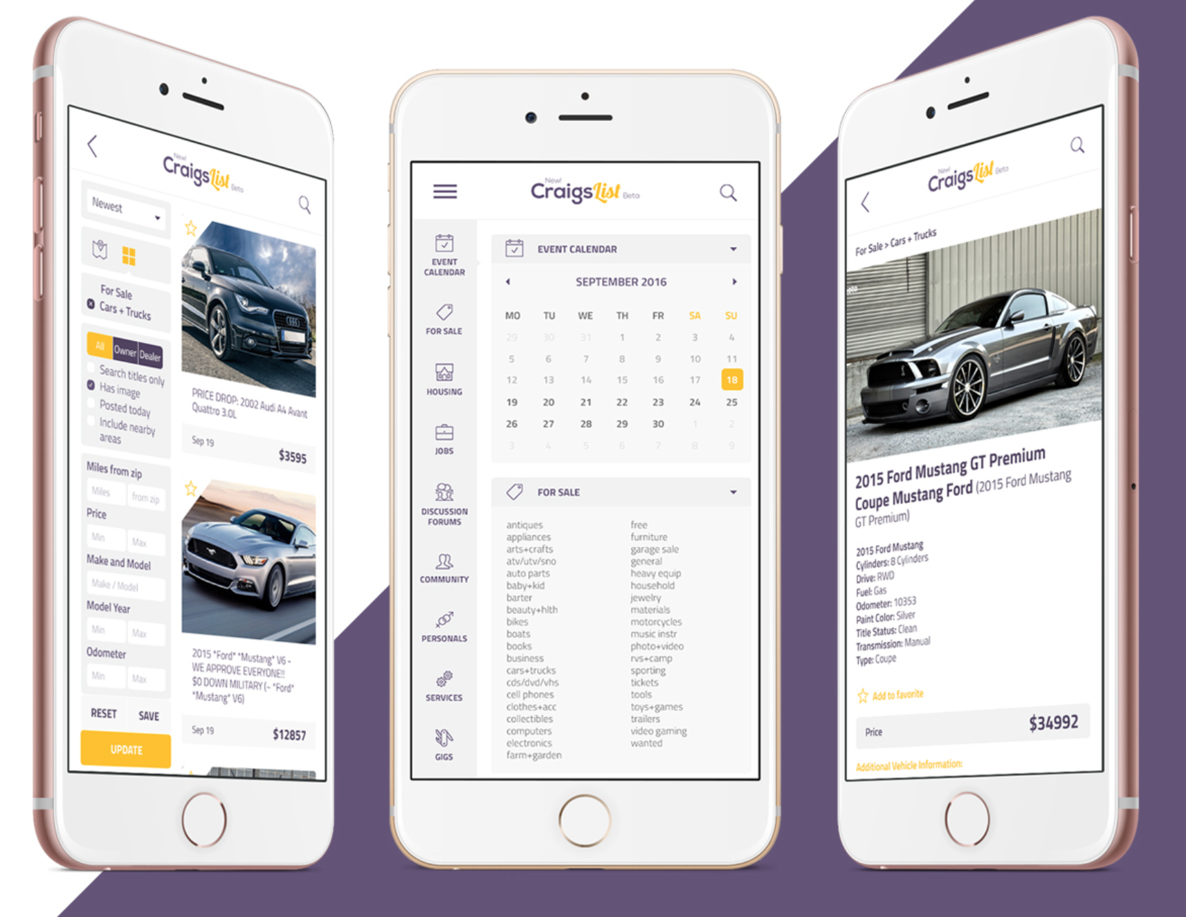

# TESTING

As Craigslist is the most popular website so for the usability of the current I assessed from the users views all over the internet. Many forums and places where Users have talked about it's wrong points and what is the good points. Considering all the reviews I tried to redesign. As an initial testing of my redesigned mockups to have users from all ages I asked many friends, family members to review my designs. In result of which I made many changes from my initial to final Mockups in relation to color, fonts and placing of data. As a result of which the competence level of redesigned version increased. The placement of search box, Data with Icons, Grouped links in the Footer, Filters for the product selections, Adding colors to the whole website gave the users a better sense of the site and increased the usability. Added Bread Crumbs and Drop Down Search box so that user can navigate back and forth easily. Adding of Automatic Slideshow on the Products page added the style and speed for users. Added Icons, a direction flow and better organization for Posting ad so that users can easily post their advertisement.

### KLM-GOMS Model

The result of the KLM-GOMS Model for the current and redesigned version is shown below. It shows the difference from 13.1 to 9.5. To do this I tried to reduce all the mental preparation time that the user puts in finding the search box and performing it by putting the search box at the top center.

Below is the KLM GOMS Model for the Search Functionality of the Current Design of Craigslist.

|  |  |  |
| --- | --- | --- |
| **ACTION** | **KLM-GOMS Code** | **Time (In Second)** |
| Hand to Mouse | H (hand to mouse) | 0.40 |
| Move mouse to browser | P (Point mouse to browser)) | 1.10 |
| Type in craigslist.org | KK(Type craigslist.org) | 14*0.20= 2.8 |
| Find the Search text box | M(Mental Preparation) | 1.20 |
| Move mouse to search menu | H(Hand to mouse) | 0.40 |
|  | M+P(search menu) | 1.20+1.10 |
| Select search menu | BB (select search menu) | 2*0.10 = 0.2 |
| Click on text link | (M+P) (find text menu item) | 1.20+1.10 |
|  | H(Hand from mouse to keyboard) | 0.40 |
| Enter search term **cars** | KK(type leather couch) | 4*0.20 (Avg typist) = 0.8 |
| Click the Enter button at keyboard | B(Button Press) | 0.10 |
| Click on the Item selected | M+P(Point mouse on the object chosen) | 1.10 |
| Total |  | 13.1 |

Below is the KLM GOMS Model for the Search Functionality of the Redesigned Version

|  |  |  |
| --- | --- | --- |
| **ACTION** | **KLM-GOMS Code** | **Time (In Second)** |
| Hand to Mouse | H (hand to mouse) | 0.40 |
| Move mouse to browser | P (Point mouse to browser)) | 1.10 |
| Type in craigslist.org | KK(Type craigslist.org) | 14*0.20= 2.8 |
| Move mouse to search menu | H(Hand to mouse) | 0.40 |
|  | P(search menu) | 1.10 |
| Select search menu | BB (select search menu) | 2*0.10 = 0.2 |
| Click on text link | (P) (find text menu item) | 1.10 |
|  | H(Hand from mouse to keyboard) | 0.40 |
| Enter search term **cars** | KK(type leather couch) | 4*0.20 (Avg typist) = 0.8 |
| Click the Enter button at keyboard | B(Button Press) | 0.10 |
| Click on the Item selected | M+P(Point mouse on the object chosen) | 1.10 |
| Total |  | 9.5 |

# Challenges Of Redesign

Before we get into the specifics of our suggestions for change, let’s take a look at some of the challenges of redesigning a website like Craigslist.

### 1. ORGANIZATION

There’s so much content on Craigslist, with hundreds of different local communities and lots of different categories of classifieds. Any website with this amount of content will face a challenge of organization in terms of structure and navigation.

Of course, the goal is to make it easy to move through the website and find what you want, making it necessary to include plenty of navigational options while minimizing clutter.

### 2. IMPROVING THE WEBSITE WITHOUT DETRACTING FROM THE BRAND

There are a number of different ways to improve the design of Craigslist and reorganize the presentation of data, but improving the design without straying too far from the current basic approach that has contributed so much to the success of the website is a major challenge. Creating a more attractive design and improving usability are both very achievable, but doing so while maintaining the essence of the company and website is not so easy. Because Craigslist’s identity is so closely connected to the website in its current state, severe changes to the aesthetics of the website could have a major negative impact on the company’s success.

### 3. IMPROVING USABILITY WITH ONLY MINOR CHANGES

Because so many people throughout the world have used Craigslist to post classifieds, and because so many of them are repeat users, any changes to the process of using the website should be thoroughly considered before being implemented. Even if a website lacks in some area of usability, making “improvements” can negatively impact users who have become accustomed to doing things a certain way.

Regular users know how the website works, and the process is usually easy for them, even if it isn’t so simple for new users. Because Craigslist is so firmly established and the community of users is so large that usability improvements that would confuse regular visitors and make it more difficult for them to use the website should be avoided at all costs.

# CONCLUSION

While these changes can lead to a design that wows visitors, they would also help make the website more visually appealing overall and, most importantly, more usable. The goal was to create a simple design that keeps the essence of Craigslist while addressing some of its weaknesses. I think I was able to implement all the HCI principles that were taught in the class to redesign it and present the Final Report. And I hope craigslist may consider redesigning its UI.